INTRODUCTION TO EXPERIMENTAL DESIGN
01:960:490:01

SECOND EXAM SPRING 2020
The red number in italic font shows the penalty for a wrong answer
ANSWER PAGE (to be uploaded into CANVAS)
1. (a) Sketch the interaction plot

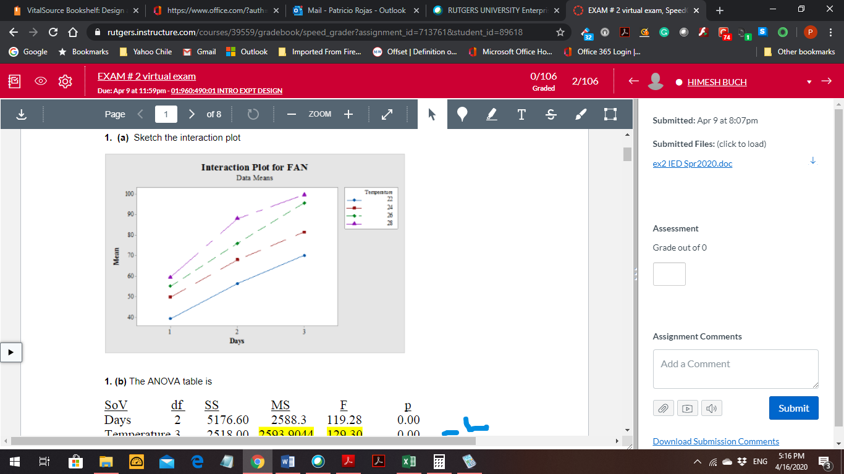 -2

1. (b) The ANOVA table is
SoV df SS MS F p
Days 2 5176.60 2588.3 119.28 1.2067e-08
Temperature 3 2518.00 839.3 38.67 1.9085e-06 -4
Interaction 6 142.00 23.67 1.09 0.42126
Error 12 260.38 21.7
Total 23 8096.98

1. (c) Write the final model that you recommend after this ANOVA analysis:

Y_{i j} = μ + α_{i} + β_{j} + ε_{i j} ε_{i j} ~ NID(0, σ² ) -2

i = 1, 2, 3 (Days) j = 1, 2, 3, 4 (Temperature) n = 2 replications

2. (a) What do you think is the objective of this experiment? (Please circle your answer)

(1) To find the conditions to kill the virus

(2) To find the conditions to increase the virus growth -2

(3) To find the conditions to decrease the virus growth

2. (b) Present an sketch of the interaction:
-2
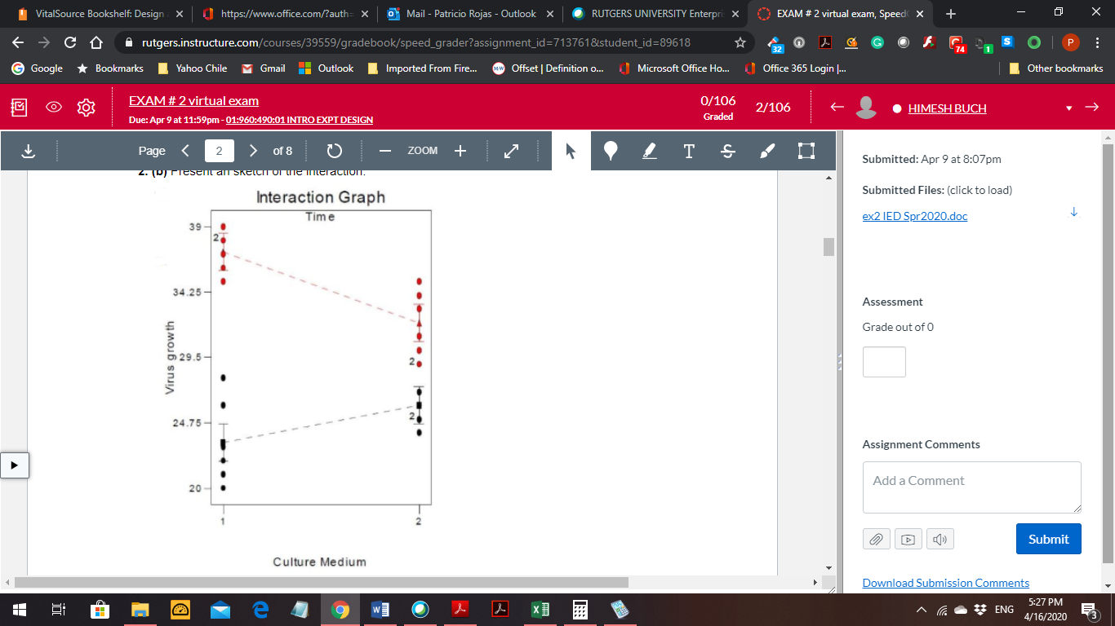

2. (c) Your conclusion from the ANOVA table and the interaction plot is: (please circle your answer)

(1) Factor B (Time) is the only significant factor that explains the viral growth.

(2) Factor B is significant, but its influence on the viral growth depends on Factor A. -2

(3) Factor A is significant since there is a significant interaction with Factor B.

2. (d) After an analysis of the residuals from fitting this 2² model with n = 6 your conclusion on data normality and constant variance is: (please circle your answer)

(1) The plots show data that is basically normal with constant variance

(2) The plots show data is normal, but a Shapiro-Wilk test is needed to test the
homogeneity of the variance since the residuals show a somewhat funnel
shape -2

(3) The plots show data is normal, but a Levene test is needed to test the
homogeneity of the variance since the residuals do not appear equally
dispersed at each predicted value

(4) The plots show data not perfectly normal, thus a normality test is needed
:

3.- (a) Then the number of blocks generated is _____4_________ -2
3.- (b) The generalized interaction that gets confounded is ______ ABCD____________ -2
3.- (c) If two of the blocks are: [a, d, abc, bcd, be, abde, ce, acde]
[(1), ad, bc, abcd, abe, bde ace, cde]

Then the next two blocks are [ b, abd, c, acd, ae, de, abce, bcde ] -2

[ e, ade, bce, abcde, ab, bd, ac, cd ] -2

4. - (a) Which fraction and resolution is this experiment?

Fraction = __1/2_______ Resolution = __4______ -4

4. – (b) If the basic design is given by the factors A, B, and C, define the column for D using the minus and plus signs

From Table 8.3 + - - + - + + - -4

c) The alias of D is _____-ABC___________

and the alias of A is _____-BCD___________ -4

d) If the estimate for A in this fraction is [A]’ = 19, what is the alias structure of this estimate?

[A]’ → A – BCD -2

e) If an estimate of A from the fraction obtained using the relation I = ABCD is [A] = 24.25, find the estimates of A and its alias.
A = ½([A] + [A]’ ) = ½( 24.25 + 19) = 21.625 -4

BCD = ½([A] - [A]’) = ½( 24.25 - 19) = 2.625

